SIMATS ENGINEERING

ASSESSMENT TOOL 2

NAME: K. VENKATA SATWIK
REGISTER NUMBER:192525270

COURSE NAME: Database Management Systems

COURSE CODE: CSA0501

COURSE OUTCOME COVERED

CO1: Analyze DBMS architecture, different data models, schema types, and design ER/EER diagrams, relational schemas for case-based scenarios by identifying entities and relationships. (BL1, BL2)

Activity Tool: Concept Mapping (Medium) Assessment Tool Weightage: 35%

QUESTIONS Total Marks: 50
Q.N  o | Question | Bloom's Level | Marks
1 | Construct a concept map linking the following terms: DBMS, Schema, Instance, Data Model, ER Diagram, Entity, Attribute, Relationship. | BL2 – Understand | 5
2 | Create a concept map for the three-level ANSI/SPARC architecture showing data independence at each level. | BL2 – Understand | 5
3 | Map the relationship between file-based systems and database systems, highlighting the problems solved by DBMS. | BL2 – Understand | 5
4 | Design a concept map for ER diagram components: entity, weak entity, attribute types, relationship types, and participation constraints. | BL2 – Understand | 5
5 | Construct a concept map comparing Hierarchical, Network, and Relational data models with their key properties. | BL2 – Understand | 5
6 | Develop a concept map for the EER model showing how it extends the basic ER model with generalization, specialization, and aggregation. | BL2 – Understand | 5

7 | Create a visual concept map for the DBMS software architecture, illustrating the flow from user request to data retrieval. | BL2 – Understand | 5
8 | Map the data models discussed in CO1 to real-world applications and explain the suitability of each model. | BL2 – Understand | 5
9 | Construct a concept map for schemas and instances, showing how they relate to physical and logical data independence. | BL2 – Understand | 5
10 | Design a concept map for the roles and responsibilities in a DBMS environment: DBA, End User, Application Developer. | BL1 – Remember | 5

Code of Conduct:

I K. VENKATA SATWIK (192525270) (Name / Reg No) certify that this submission is my original work and that I have adhered to the guidelines specified for this assessment. I understand that any violation of academic integrity rules will result in disciplinary action.

Signature of the student: Satwik

RUBRICS FOR CALCULATION:

Criteria | Weightage | Level 4 (Exemplary) | Level 3 (Proficient) | Level 2 (Developing) | Level 1 (Beginning)
Concept Identification | 25% | Identifies all key concepts from literature accurately and comprehensive ly | Identifies most key concepts with minor omissions | Identifies limited concepts; some are irrelevant or missing | Fails to identify essential concepts
Linkages | 25% | Establishes clear, meaningful, and accurate relationships between concepts | Shows correct relationships with minor gaps | Relationships are weak, unclear, or partially incorrect | No meaningful relationships established
Organization | 20% | Concepts are well-structured hierarchically with logical flow  and grouping | Mostly organized with minor structural  issues | Some organization but lacks clear  hierarchy | No logical organization or structure

Integration of Literature | 20% | Integrates multiple studies effectively to show connections and  comparisons | Shows some integration of literature | Limited integration; mostly isolated concepts | No integration of literature evidence
Clarity | 10% | Concept map is clear, neat, visually structured, and easy to interpret | Generally clear with minor readability issues | Clarity is reduced; difficult to interpret in parts | Poorly presented and hard to understand

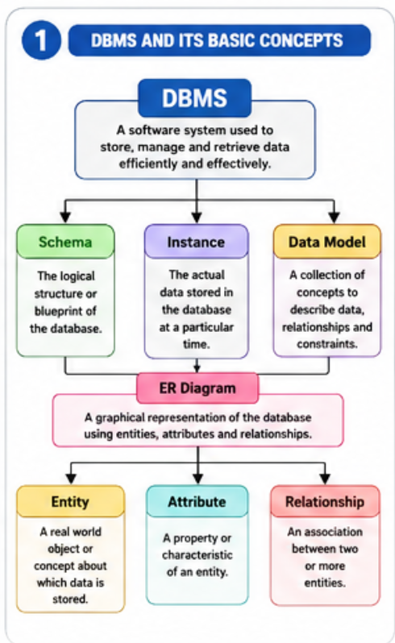

- DBMS organizes and manages data efficiently using schemas, instances, and data models.
2. ER diagrams help represent entities, attributes, and relationships in a database.
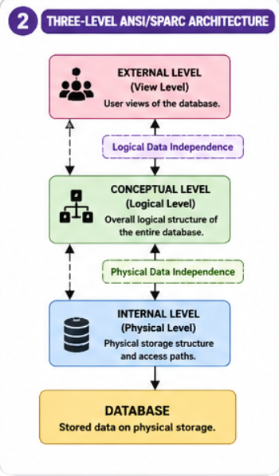

1. The three-level architecture separates user views, logical design, and physical storage.
2. It provides logical and physical data independence for better database management.

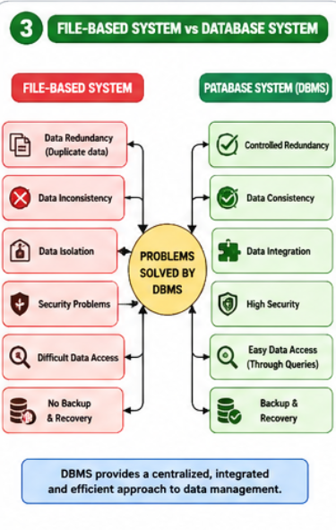

1. DBMS overcomes the limitations of file-based systems such as redundancy and inconsistency.
2. It provides secure, reliable, and centralized data management.
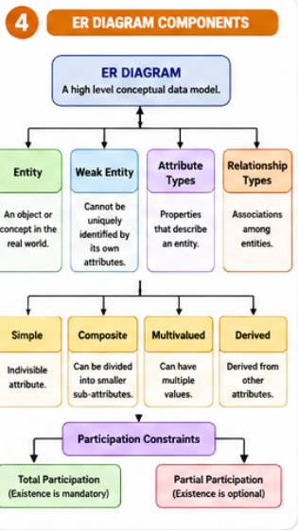

1.ER diagrams simplify database design by representing entities and relationships visually.
2. Different attribute and relationship types improve the accuracy of database modeling.
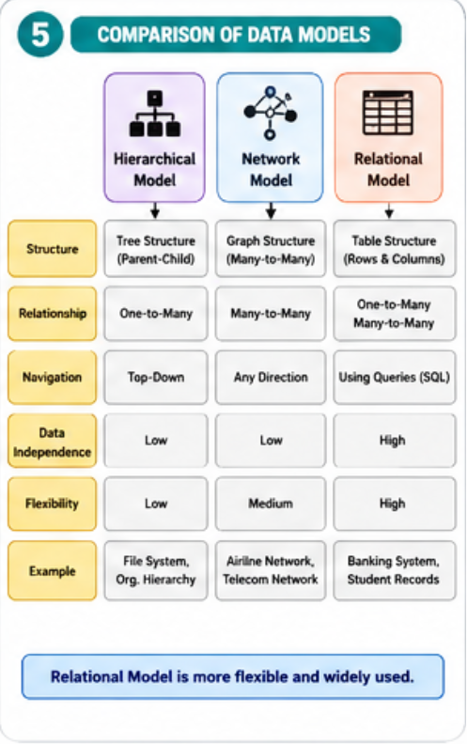

1. Each data model has unique features and is suitable for different applications.
2. The relational model is the most widely used because of its simplicity and flexibility.
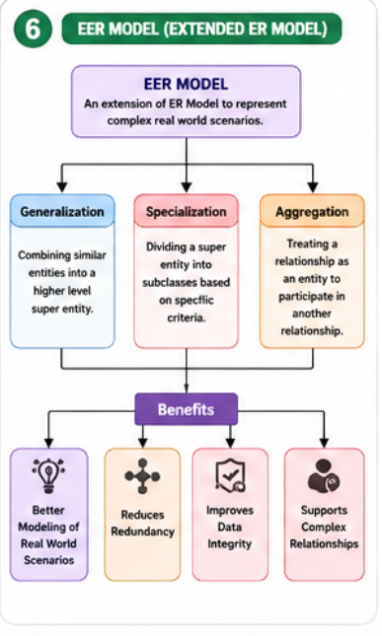
1. The EER model extends the ER model with advanced concepts like specialization and aggregation.
2. It is useful for designing complex real-world database systems.

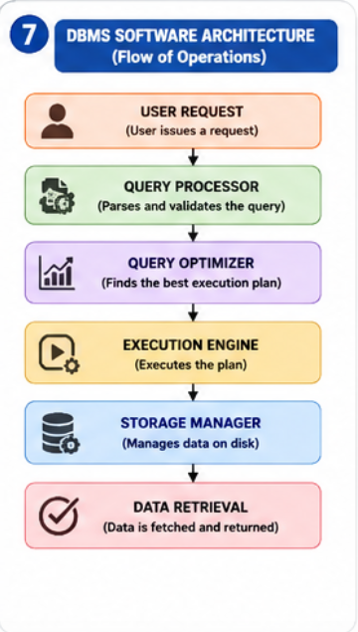

1. DBMS processes user requests through query processing and storage management.
2. This architecture ensures efficient and accurate data retrieval.

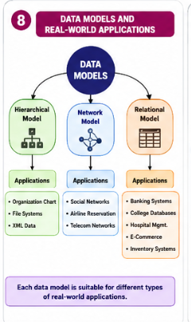

1. Different data models are selected based on application requirements.
2. Choosing the right model improves database performance and scalability.

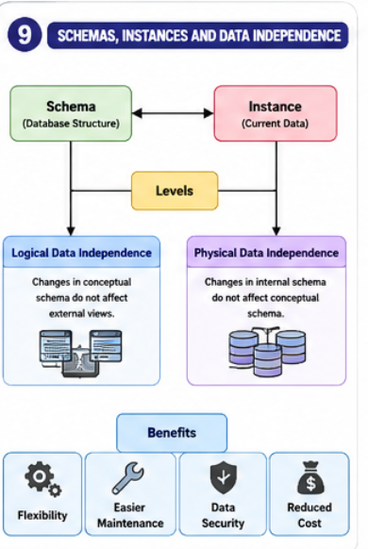

1. Schemas define the database structure, while instances represent current data.
2. Data independence allows modifications without affecting users or applications.

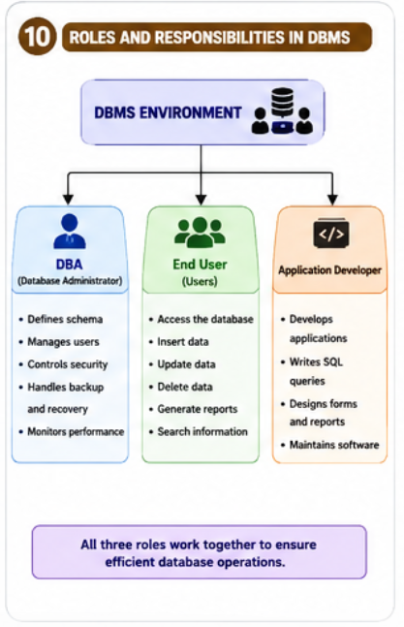

1. DBA, end users, and application developers work together for efficient database operations.
2. Their responsibilities ensure database security, maintenance, and effective usage.

